EXPERIMENT- 10

REG- 16BIT0453
NAME- KRISHNA KUMAR MAHTO

CODE:

#include<stdio.h>
#include<stdlib.h>

// 1 disk unit each of MAX_DISK_DISK is equal to 512 Bytes
#define MAX_DISK 5
#define occupied 1
#define free 0

// 1 index location represents 1 block of disk = 512 Bytes
int disk[MAX_DISK];
int file_size = 2;

void contiguous()
{
int i,flag[MAX_DISK];

for(i=0;i<MAX_DISK;i++)
{
if(disk[i] == free)
{
disk[i] = occupied;
flag[i] = 1; // indicates ith disk space got occupied
if(i != 0 && flag[i-1] == 1)
{
puts("File allocation completed");
return ;
}
continue;
}
if(disk[i] == occupied && flag[i-1] == 1)
{
puts("Contiguous allocation not possible.");
return ;
}
}
}

void indexed()
{
int file_index[2], i, j=0,limit = file_size;

for(i=0;i<MAX_DISK && limit;i++)
{
if(disk[i] == free)
{
disk[i] = occupied;
file_index[j++] = i;
limit--;
}
}
if(j==2)
{
puts("File allocation successful");
printf("Following is the status of the file index:\nfile 1: %d\nfile 2: %d\n",file_index[0],file_index[1]);
return ;
}
else
{
puts("Indexed allocation not possible.");
return ;
}

}

void linked()
{
typedef struct linked_disk
{
int space;
struct linked_disk* next;
}LD;

LD *head, *new;

head = (LD*)malloc(sizeof(LD));
head->space = occupied;
head->next = NULL;

new = (LD*)malloc(sizeof(LD));
new->space = occupied;
new->next = NULL;
head->next = new;

LD *temp;

puts("File allocation completed.");
}

int main(int argc, char* argv[])
{
int choice,i,j;

puts("Vacant disk locations type:\n1. Contiguous?\n2. Non-contiguous?");
scanf("%d",&choice);

switch(choice)
{
case 1:
for(i=0;i<MAX_DISK;i++)
disk[i] = free;
break;

case 2:
for(i=0;i<MAX_DISK;i++)
{
if(i%2 == 0)
disk[i] = occupied;
else
disk[i] = free;
}

}

do
{

puts("");

puts("Select allocation type:\n1. Contiguous\n2. Indexed\n3. Linked\n4. Exit");
scanf("%d",&choice);
switch(choice)
{
case 1:
contiguous();
break;

case 2:
indexed();
break;

case 3:
linked();
break;

case 4:
exit(0);
}
}while(1);

return 0;
}

OUTPUT:

1. contiguous memory availability

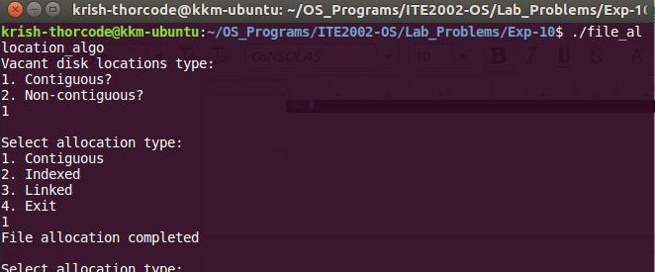

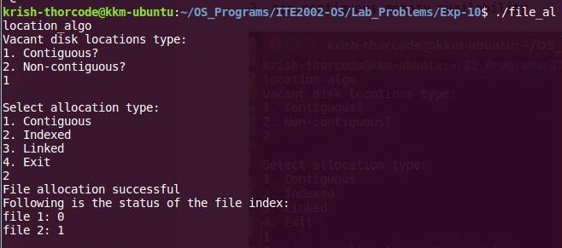

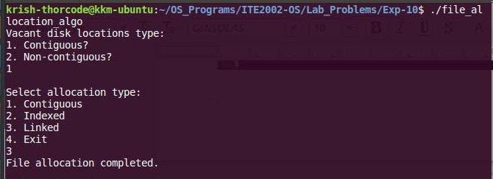

2. non-contiguous memory availability
